1. Train the NN for the O2 model – larger layer numbers 1-5

Same results.

1. **Train the NN for the Ar model – same structure**

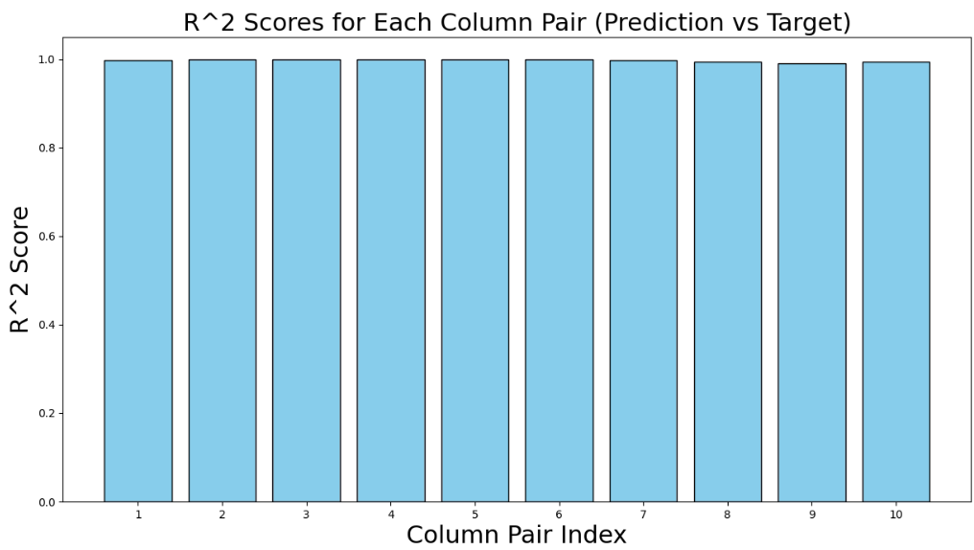

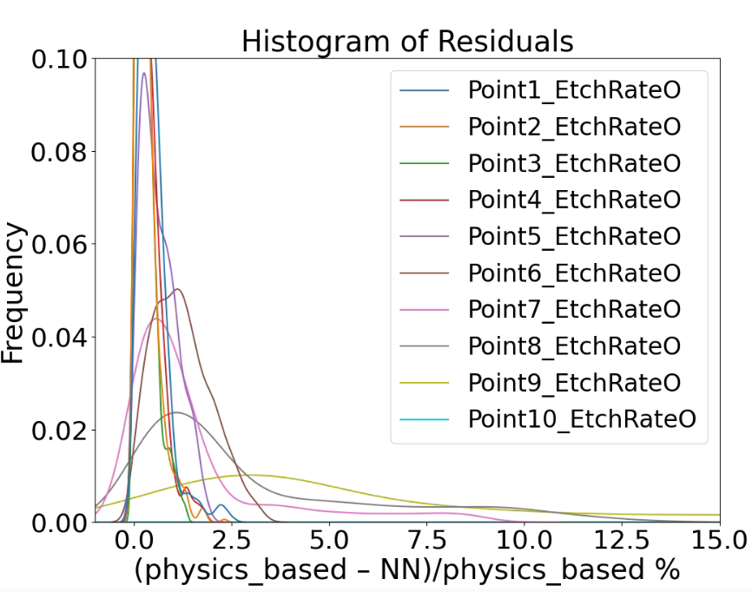

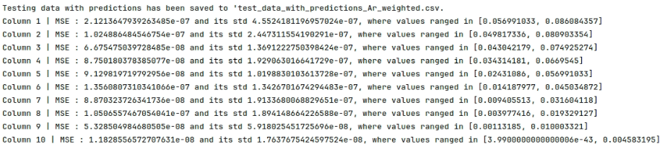

1. Test the NN with min max normalization

Retuning should be done with min max (running at lab pc)

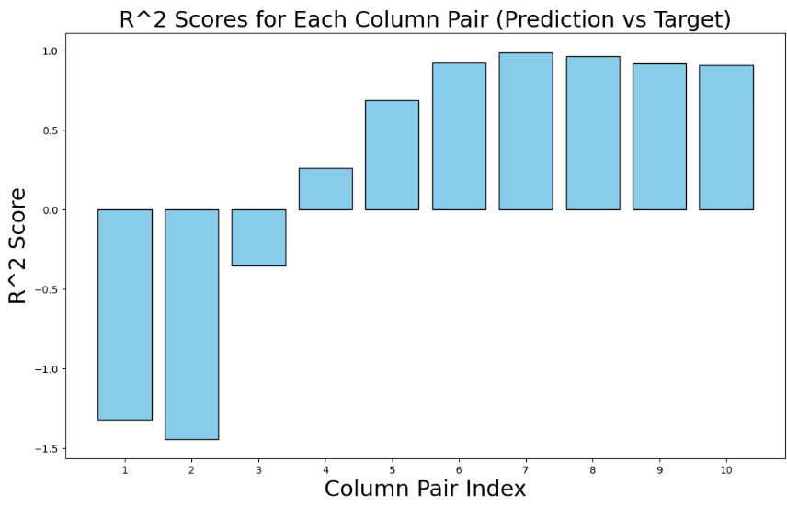

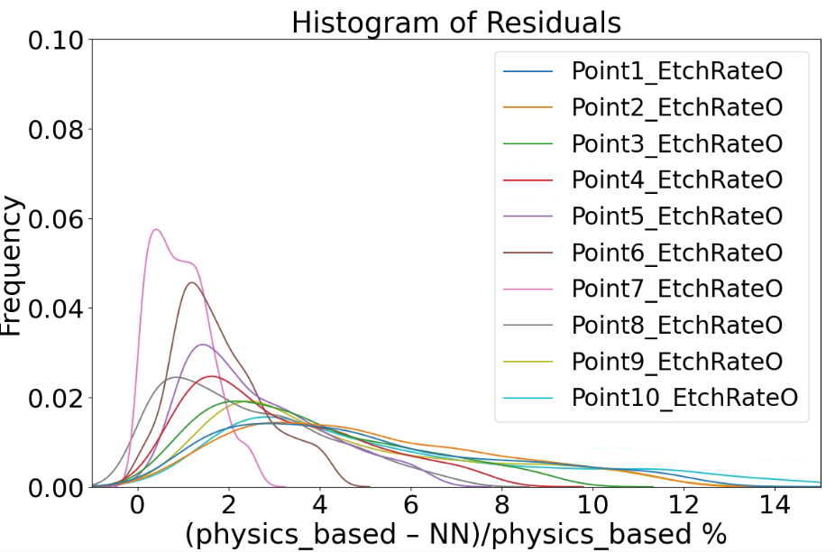

1. Tune and train the NN by randomizing the outputs. Not point 1 through 10 but randomly. Also adjust the weighted mse function.

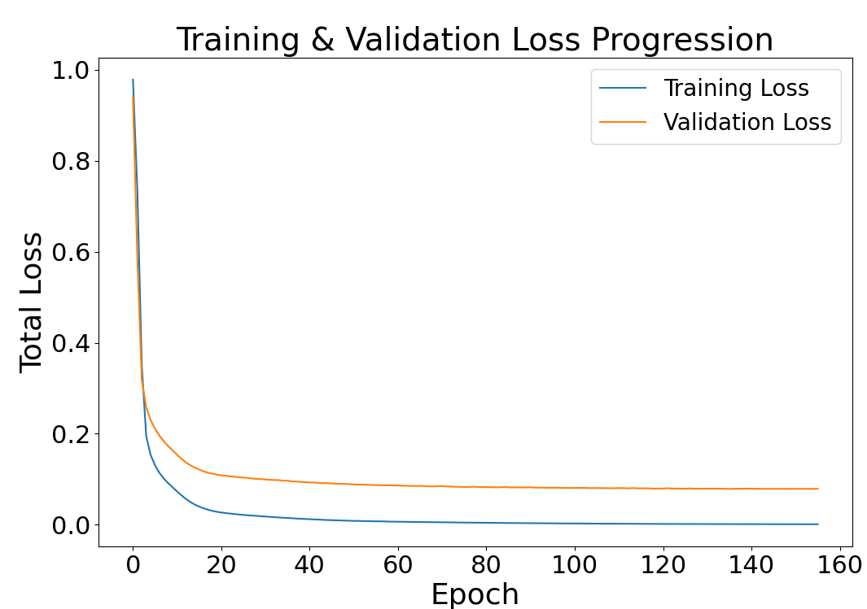

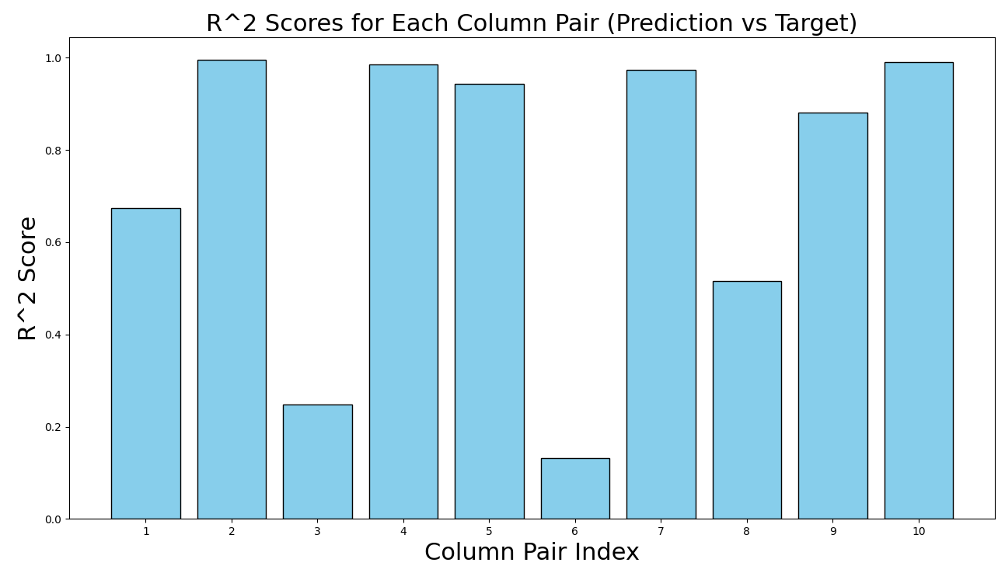

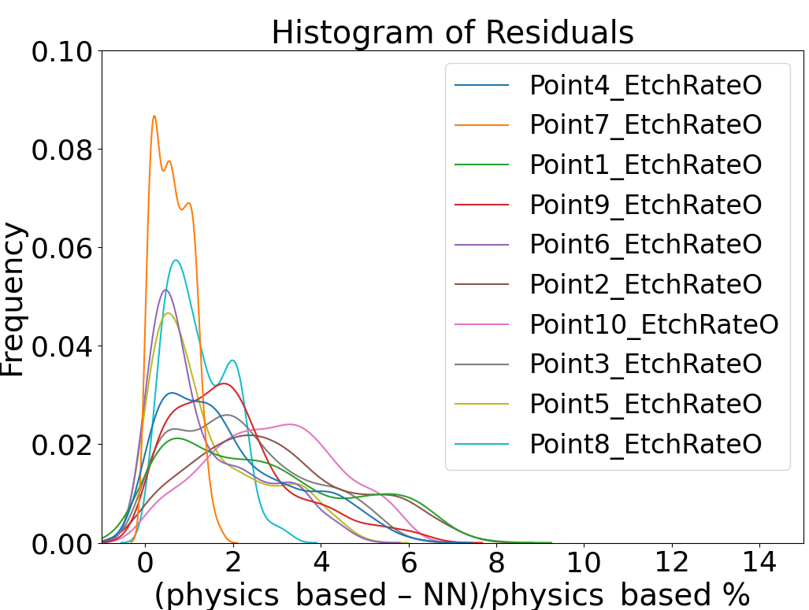

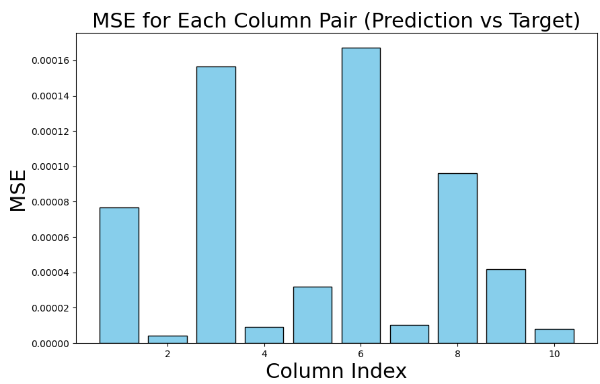

After rearranging the points from 1 to 10: the R^2 score: